Week 15

* JPA
  + Add maven dependencies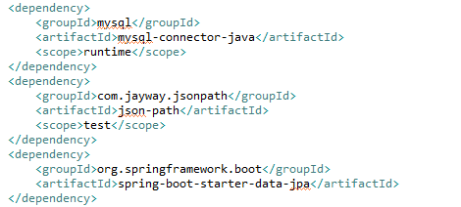
  + Add application.properties to src/main/resources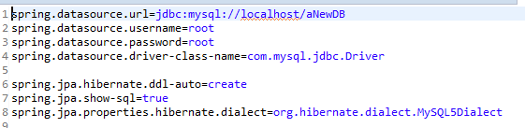
  + Add entities 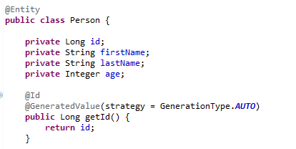
  + Create db in mysql console
  + Create repository
  + Create service
  + Autowire repository in service
  + Autowire service in controller
  + Implement full crud